Europass  Curriculum Vitae |  | 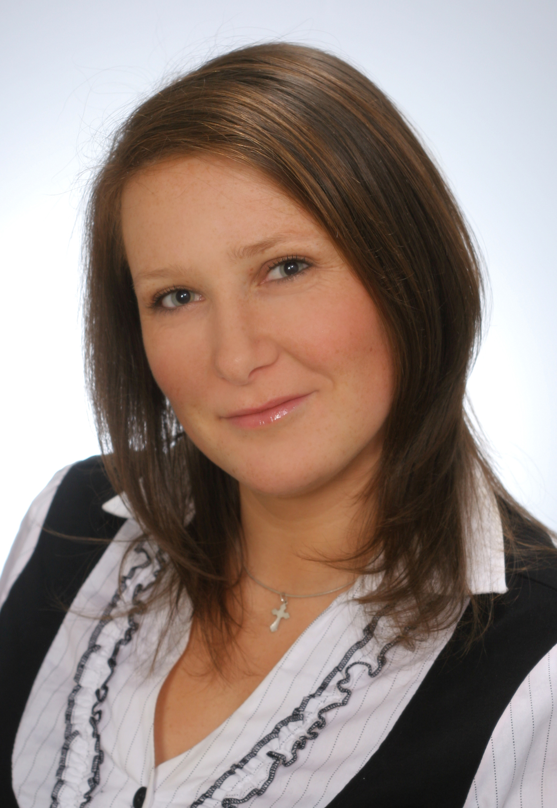
Personal information
First name(s) / Surname(s) |  | GOŚCINIAK Daria
Address(es) |  | Piotrowo 3 ,  PL - 60-965 Poznań
Telephone(s) |  | - |  |  |  |  | Mobile: |  |  |  | +48 696-273-749
Fax(es) |  | -
E-mail |  | daria_87@wp.pl
Nationality |  | Polish
Date of birth |  | 08.03.1987
Gender |  | Female
Desired employment / Occupational field |  | Engineer – Management of Production
Work experience |  | -
Dates
Occupation or position held
Main activities and responsibilities
Name and address of employer
Type of business or sector
Education and training
Dates  Principal subjects/occupational skills covered  Name and type of organisation providing education and training  Dates |  | 2009 - present  Management of Production, Logistics. Production systems  University of Technology in Poznań  Piotrowo 3  PL – 60 – 965 Poznań  2006 - 2009
Title of qualification awarded |  | Eng.
Principal subjects/occupational skills covered |  | Management of Production, Logistics. Production systems
Name and type of organisation providing education and training |  | University of Technology in Poznań  Piotrowo 3  PL – 60 – 965 Poznań
Personal skills and competences
Mother tongue(s) |  | Polish
Other language(s) |  | English, German
Self-assessment |  |  | Understanding |  |  |  |  | Speaking |  |  |  |  | Writing
European level (*) |  |  | Listening |  | Reading |  |  | Spoken interaction |  | Spoken production
English |  |  | B2 | Independent user | B1 | Basic user |  | B1 | Basic user | A2 |  | Basic user | A1 | Basic user
German |  |  | B2 | Independent user | B1 | Basic user |  | B1 | Basic user | B1 |  | Basic user | B1 | Basic user
 |  | (*) Common European Framework of Reference for Languages
Social skills and competences |  | I am an active and communicative person, I am always involved in activities which imply communication skills and teamwork
Organisational skills and competences |  | I am well organised. Punctual, responsible, serious.
Technical skills and competences |  | - Team work  - Initiative  - Good communication skills
Computer skills and competences |  | Microsoft Word, Microsoft Excel, Microsoft Access, Microsoft Outlook Microsoft PowerPoint, Adobe Reader, Corel Draw, Internet.
Artistic skills and competences |  | -
Driving licence |  | B
Additional information |  | References available upon request
Annexes |  | -

ID: ASK062198

