Europass  Curriculum Vitae |  | 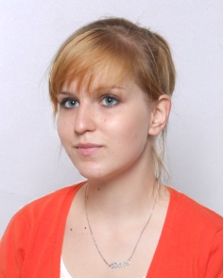
Personal information
First name(s) / Surname(s) |  | Pamela Rypińska
Address(es) |  | Św.Rocha 11A/705 Street, Poznan, Poland
Telephone(s) |  | - |  |  |  |  | Mobile: |  |  |  | -
Fax(es) |  | -
E-mail |  | Pamela.rypinska@gmail.com
Nationality |  | Polish
Date of birth |  | 01/11/1990
Gender |  | Female
Desired employment / Occupational field |  | -
Education and training |  | -
Dates  Title of qualification awarded  Principal subjects/occupational skills covered  Name and type of organisation providing education and training |  | 2009 –  Preparation to obtain the degree of Bachelors of Science in Management and Production Engineering  Management, Production Engineering, Economics  Poznan University of Technology
Mother tongue(s) |  | Polish
Other language(s) |  | English
Self-assessment |  |  | Understanding |  |  |  |  | Speaking |  |  |  |  | Writing
European level (*) |  |  | Listening |  | Reading |  |  | Spoken interaction |  | Spoken production
English |  |  |  | B2 |  | C1 |  |  | B2 |  |  | B2 |  | B2
 |  | (*) Common European Framework of Reference for Languages
Computer skills and competences |  | Microsoft Office (Word, Power Point, Excel)
Driving licence |  | B

Number of Identity Card: APT 507 701

