 |  | 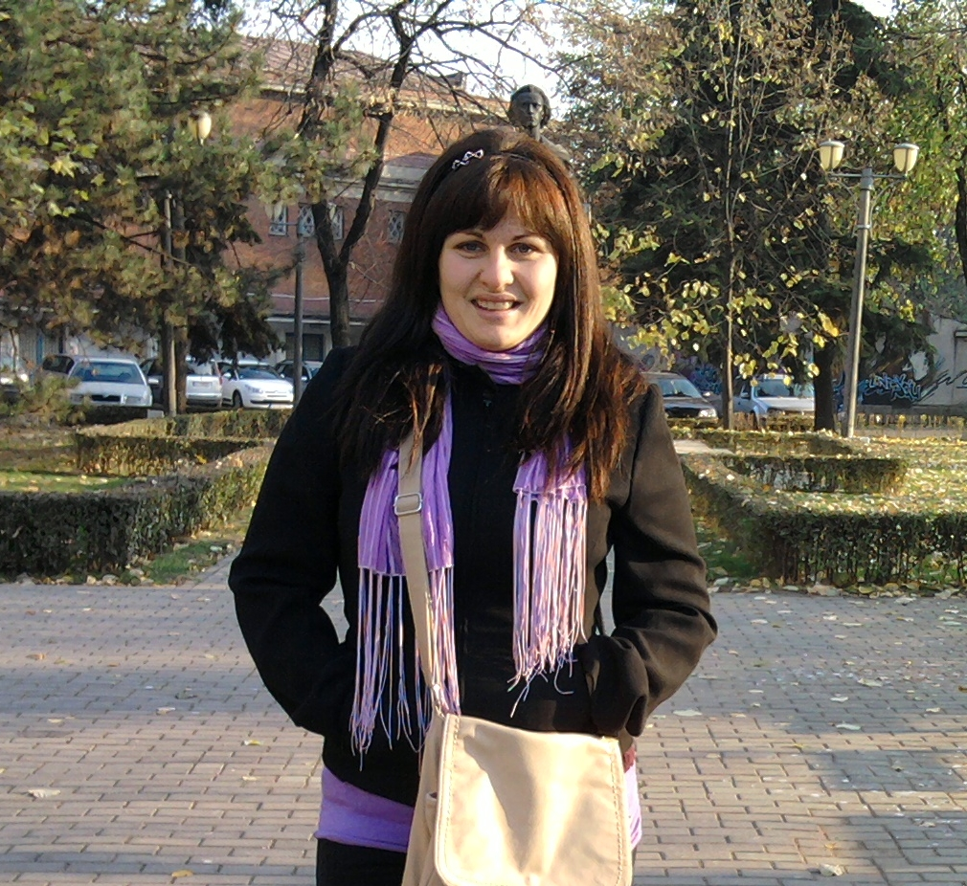
Europass
Curriculum Vitae
Personal information
First name(s) / Surname(s) |  | Alina Giorgiana, Soare
Address(es) |  | Aleea Buzias, Bl. 1A, Sc. 1, Ap. 2, Resita, Caras-Severin County
Telephone(s) |  | 0040 355 808083 |  |  |  |  | Mobile: |  |  |  | 0040 764 608280
E-mail |  | mandinga_alina@yahoo.com
Nationality |  | Romanian
Date of birth |  | 16.05.1990
Gender |  | Female
Work experience
Dates |  | April 2010 – September 2010
Occupation or position held |  | Sales Agent
Main activities and responsibilities |  | Promoting health products at conventions
Name and address of employer |  | Winalite
Type of business or sector |  | Health care
Dates |  | 2006 - 2010
Occupation or position held |  | Sales Agent
Main activities and responsibilities |  | Selling Company products
Name and address of employer |  | Oriflame Romania
Type of business or sector |  | Cosmetics
Dates |  | 2004 - 2008
Occupation or position held |  | Sales Agent
Main activities and responsibilities |  | Selling Company products
Name and address of employer |  | Avon Romania
Type of business or sector |  | Cosmetics
Education and training
Dates |  | 2009 - present
Title of qualification awarded |  | Student
Principal subjects/occupational skills covered |  | Industrial Management, Economy, Accounting basics  Mechanical engineering
Name and type of organisation providing education and training |  | Polytechnic University Timisoara  Faculty of Management in Productoin and Transports  Domain: Engineering and Management
Dates |  | 2005 - 2009
Title of qualification awarded |  | Computer programmer
Principal subjects/occupational skills covered |  | Informatics
Name and type of organisation providing education and training |  | Mircea Eliade Theoretical Highscool
Personal skills and competences
Mother tongue(s) |  | Romanian
Other language(s)
Self-assessment |  |  | Understanding |  |  |  |  | Speaking |  |  |  |  | Writing
European level (*) |  |  | Listening |  | Reading |  |  | Spoken interaction |  | Spoken production
English |  |  | B2 | Independent user | B1 | Independent user |  | B2 | Independent user | B2 |  | Independent user | C1 | Independent user
German |  |  | A2 | Basic user | A2 | Basic user |  | A2 | Basic user | A2 |  | Basic user | A2 | Basic user
Language |  |  | A2 | Basic user | A2 | Basic user |  | B1 | Independent user | B1 |  | Independent user | A1 | Basic user
 |  | (*) Common European Framework of Reference for Languages
Social skills and competences |  | Good communication skills (Promoting products trough direct contact to customer for several companies, participation at conventions, sales agent).  Team spirit. Adaptability.
Organisational skills and competences |  | Good organisational skills (Arranging halls for weddings)
Technical skills and competences |  | Computer operating and programming certificate  Participation in several financial consultants seminaries  Course in Managerial and entrepreneurial competences for business starting and self employment.
Computer skills and competences |  | Good Microsoft Office skills (Word, Excel, Power Point, Publisher)  Good programming skills (Turbo Pascal, C++)  Good database knowledge (Fox Pro)  Good CAD knowledge (AutoCAD)
Artistic skills and competences |  | Photography, travel, tennis, swimming
Other skills and competences |  | Basic experience in banking and insurance fields (internship at BRD Group Societee Generale Bank, sales training at Marshally Associated Insurance)

