Europass  Curriculum Vitae |  | 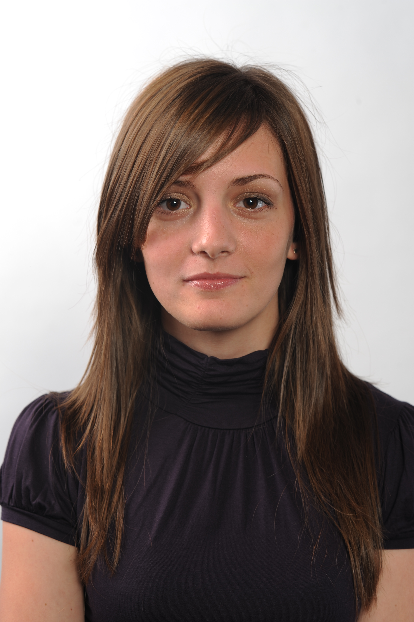
Personal information
First name(s) / Surname(s) |  | Zaro Alexandra-Oana
Address(es) |  | Electronicii street, no 17 B11 ap 20 , 300694 Timisoara, Romania
Telephone(s) |  |  |  |  |  |  | Mobile:0744553581
E-mail |  | alexandra_zaro@yahoo.com
Nationality |  | Romanian
Date of birth |  | 19.07.1990
Gender |  | female
Education and training
Dates |  | 2013-2009 Student at Faculty of Management in Production and Transportation  2009-2005 Student at « C.D. Loga » High School
Title of qualification awarded |  | Baccalaureate diploma
Principal subjects/occupational skills covered |  | Mathematics  informatics  english
Name and type of organisation providing education and training |  | « C.D. Loga »High School, , real profile
Personal skills and competences
Mother tongue(s) |  | Romanian
Other language(s) |  | 1.English  2.German
Self-assessment
European level (*) |  |  | Understanding |  |  |  |  | Speaking |  |  |  |  | Writing
Language |  |  | Listening |  | Reading |  |  | Spoken interaction |  | Spoken production
Language |  |  | 1 | C1 | 1 | C1 |  | 1 | C1 | 1 |  | C1 | 1 | C1
 |  |  | 2 | A2 | 2 | A2 |  | 2 | A2 | 2 |  | A2 | 2 | A2

Social skills and competences | I am the President of my college Students League and I took part in activities that involved socialization, teamwork, the organization of certain events, team management, competences in solving conflicts. From this experience I learned how to be more observant, open-minded-to be able to accept ideas contrary to my own, imaginative and diplomatic.  I took part in a Personal Development Training where I learned more about the human personality, the way it reacts in different situations.  I am a fast learner, i am calm and careful and i can make good decisions when stress is included.  I am a resourceful person, I see what needs to be done and do it without being told, I explore every possible means of solving a problem.
Technical skills and competences/ Computer skills and competences | Good command of Microsoft Office tools (followed additional courses beside school), AutoCAD
Artistic skills and competences | I followed design, painting classes and decorative art
Other skills and competences | I took part in different challenges, competitions in which i have learned to work in a team
Driving licence | B category
Hobbies | Travelling, reading, swimming, drawing

