Europass  Curriculum Vitae |  | 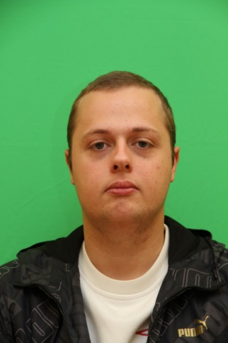
Personal information
First name(s) / Surname(s) |  | Alexandre FAUQUEMBERGUE
Address(es) |  | 16, Route Nationale, 62138,Violaines, France
Telephone(s) |  | (remove if not relevant, see instructions) |  |  |  |  | Mobile: |  |  |  | +330637072837
Fax(es)
E-mail |  | Fauquembergue.alexandre@hotmail.fr
Nationality |  | French
Date of birth |  | 26/07/1989
Gender |  | Male
Desired employment / Occupational field |  | /
Work experience
Dates |  | 3 August – 10 August 2009,3 August – 9 August 2010 :
Occupation or position held |  | Cleaning Operative at Violaines City Hall
Main activities and responsibilities |  | It was a seasonal employment, only for the young people of my town.
Name and address of employer |  | Violaines City Hall, 42 Rue Grand Place 62138 Violaines, France .
Dates |  | June - July 2010 :
Occupation or position held |  | Cleaning Operative at Ramery
Main activities and responsibilities |  | Seasonal Employment in charge of helping the worker to rebuild the road.
Name and address of employer  Type of business or sector  Dates  Occupation or position held  Main activities and responsibilities  Name and address of employer  Type of Business or sector |  | Ramery 740 Rue du Bac 59193 Erquinghem-Lys, France  Public and building working.  7 December – 28 December 2009  Trainee at ACL Bag Center  Consist in reorganizing the shelves of bags in this shop.  ACL BAG Center, Centre Commercial CARREFOUR, Route Nationale 62138 Auchy-les-Mines,France  Sales of bag
Dates  Occupation or position held  Main activities and responsibilities  Name and address of employer  Type of Business or sector  Education and training  Dates  Title of qualification awarded  Principal subjects/occupational skills  covered  Name and type of organization  providing education and training  Dates  Title of qualification awarded  Principal subjects/occupational skills  covered  Name and type of organization  providing education and training  Dates  Title of qualification awarded  Principal subjects/occupational skills  covered  Name and type of organization  providing education and training |  | December - June 2009  General-Purpose Worker  Help the worker in our different tasks.  Joinery Jean-Luc Clément, the company actually disappear  Wood Working.  09/2009 – 06/2012  Preparation of a two year university degree  Quality Logistics and Industrial Organization  Bethune Institute of Technology, Bethune 62400 , France  09/2008 – 01/2009  Preparation of a Bachelor of history  Bachelor of History  Artois University, Arras 62000, France  09/2006 – 07/2008  Preparation of a Literary high school diploma  Literary studies  High School Marguerite Yourcenar, Beuvry 62660, France.
 |  |  | Understanding |  |  |  |  | Speaking |  |  |  |  | Writing
 |  |  | Listening |  | Reading |  |  | Spoken interaction |  | Spoken production
 |  |  | B1 |  | B2 |  |  | B2 |  | B1 |  |  | B2
 |  |  | A1 |  | A2 |  |  | B1 |  | B2 |  |  | B1
 |  | Bethune Institute of Technology
Social skills and competences |  | /
Organisational skills and competences |  | /
Technical skills and competences |  | /
Computer skills and competences |  | Operating Environnements : Linux, Windows 95/98/2000/XP/Vista  Software : Microsoft Excel, Words/Works, PowerPoint, Open Office
Artistic skills and competences |  | /
Other skills and competences |  | /
Driving licence |  | Category B Since November 2010
Additional information |  | Make some party with my friends. Playing in a football team during 7 years ( 5 to 12 years ) called FC Gueroux, I play again but not in a team.
Annexes |  | List any items attached. (Remove heading if not relevant, see instructions)

