Europass  Curriculum Vitae |  | 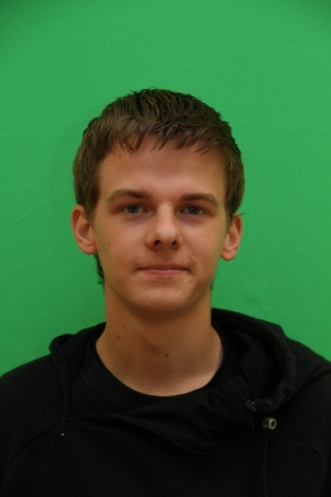
Personal information
First name(s) / Surname(s) |  | Quentin EVRARD
Address(es) |  | 9, residence Louis Blaringhem, Locon 62400 France
Telephone(s) |  | Home: 0321657813 |  |  |  |  | Mobile: |  |  |  | 0660805890
Fax(es) |  | /
E-mail |  | Quentin.Evr@gmail.com
Nationality |  | French
Date of birth |  | 23/05/1992
Gender |  | Male
Desired employment / Occupational field |  | /
Work experience |  | /
Dates |  | /
Occupation or position held |  | /
Main activities and responsibilities |  | /
Name and address of employer |  | /
Type of business or sector |  | /
Education and training
Dates |  | 09/2010-06/2012
Title of qualification awarded |  | Preparation of a two year university degree
Principal subjects/occupational skills covered |  | Quality Logistics and Industrial Organization
Name and type of organisation providing education and training |  | Bethune Institute of Technology
Level in national or international classification
Personal skills and competences
Mother tongue(s) |  | French
Other language(s)
Self-assessment |  |  | Understanding |  |  |  |  | Speaking |  |  |  |  | Writing
European level (*) |  |  | Listening |  | Reading |  |  | Spoken interaction |  | Spoken production
English |  |  | B2 |  | B2 |  |  | B1 |  | B1 |  |  | B1
Spanish |  |  | A2 |  | B1 |  |  | A2 |  | A2 |  |  | A2
 |  | (*) Common European Framework of Reference for Languages
Social skills and competences |  | /
Organisational skills and competences |  | /
Technical skills and competences |  | /
Computer skills and competences |  | Windows XP, Linux, Access, Extend (Computer Aided Production Management), Word, Excel.
Artistic skills and competences |  | /
Other skills and competences |  | /
Driving licence |  | B
Additional information |  | Enjoy all sports particularly running, cycling and handball. Like to travel and discover foreign people.
Annexes |  | /

