 |  | 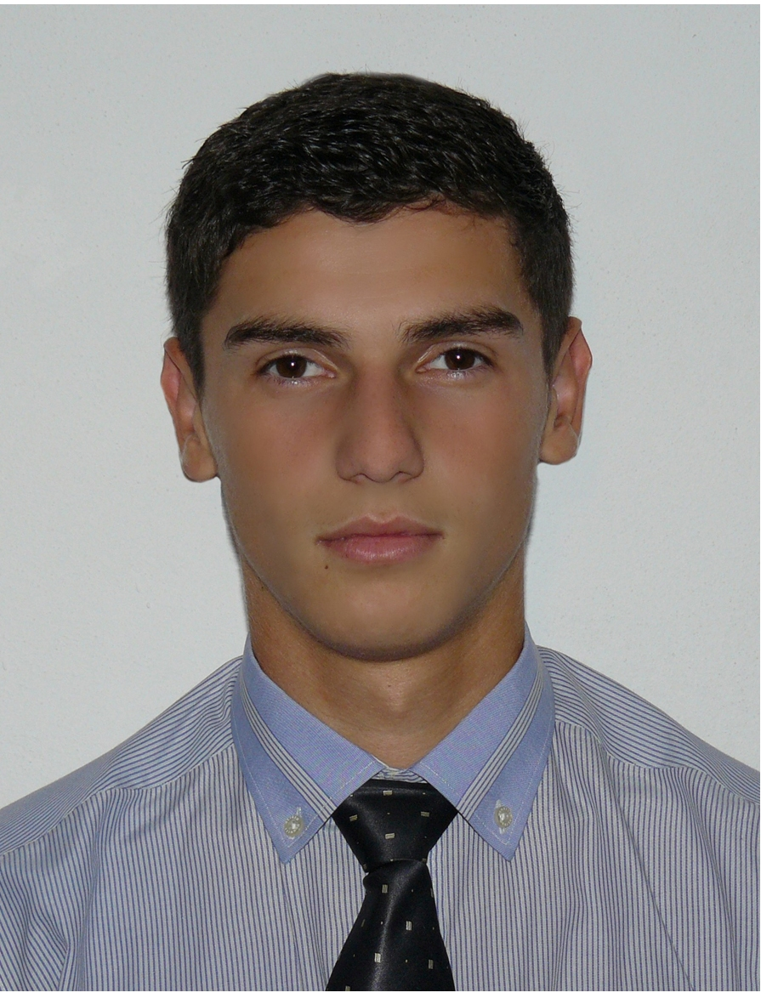
Europass
Curriculum Vitae
Personal information
First name(s) / Surname(s) |  | Crina Cristian Dumitru
Address(es) |  | Str. Aleea Romanitei,nr.3,sc.3,ap.17 Postal code 320128, Resita Caraş-Severin, România
Telephone(s) |  | (remove if not relevant, see instructions) |  |  |  |  | Mobile: |  |  |  | 0741552700
Fax(es) |  | -
E-mail |  | crina_cristian2000@yahoo.com
Nationality |  | romanian
Date of birth |  | 25.09.1992
Gender |  | male
Desired employment / Occupational field |  | -
Work experience |  | -
Education and training |  | Student at University Eftimie Murgu Resita,Faculty of Electrical engineering in the electrical, electronic and computers domain.
Dates |  | 2011 - present
Title of qualification awarded |  | Student in the first year in Electrical engineering in the electrical, electronic and computers domain.
Principal subjects/occupational skills covered |  | Mathematics and Computers
Education and training |  | High School "Mircea Eliade” Resita, specialization:Chemistry-Biology
Dates |  | 2007 - 2011
Title of qualification awarded |  | High school graduation certificate  Baccalaureate diploma  Certificate of advanced level language skills in English.
Mother tongue(s) |  | Romanian
Other language(s) |  | English,French
Self-assessment |  |  | Understanding |  |  |  |  | Speaking |  |  |  |  | Writing
European level (*) |  |  | Listening |  | Reading |  |  | Spoken interaction |  | Spoken production
English,French |  |  | A1 |  | B1 |  |  | A2 |  | A2 |  |  | A2
 |  | (*) Common European Framework of Reference for Languages
Social skills and competences |  | Able to work in a team and under stress, quick adaptability to changes, comunication
Technical skills and competences |  | PC knowledge
Computer skills and competences |  | Hardware – medium level, Software – medium level: installation  Windows XP, Vista, 7; Office (MS, Open Office) –Medium;
Other skills and competences |  | Hobby: PC in general, travelling,soccer,swimming.
Additional information |  | Session of students scientific problems, University Eftimie Murgu

