

Europass  Curriculum Vitae |  | 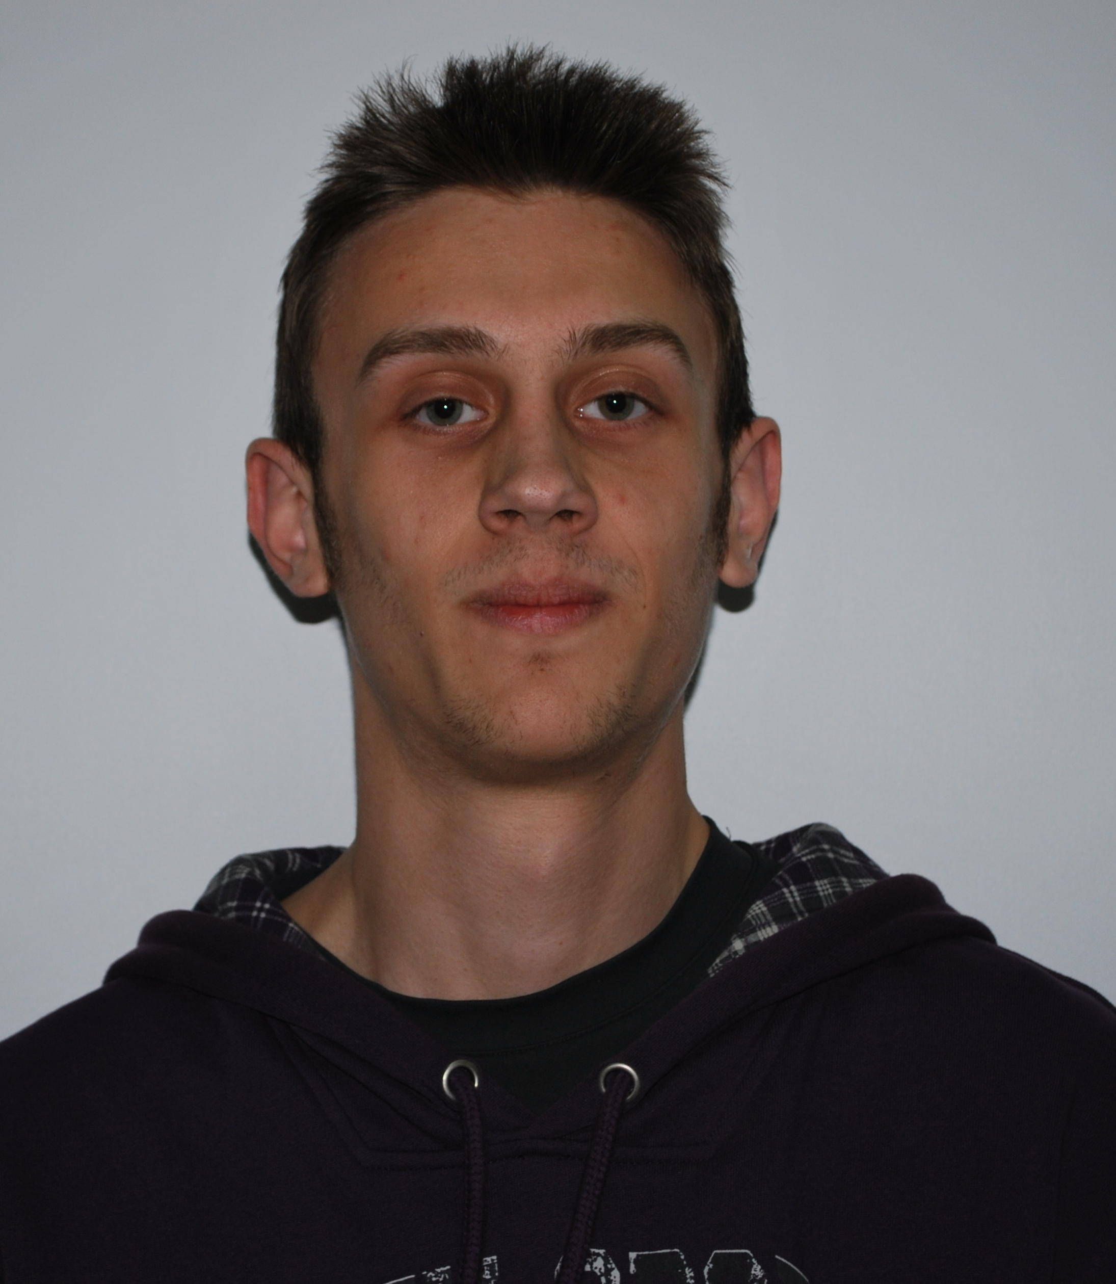
Personal information
First name(s) / Surname(s) |  | Lorinţi Ovidiu
Address(es) |  | Str. Eftimie Murgu nr.13, sc.1, et.2, ap.15, Reşiţa, cod poştal 320088, Romania
Telephone(s) |  | Mobile: +40 0724722096
Fax(es)
E-mail |  | ovidiulorinti@yahoo.com
Nationality |  | Romanian
Date of birth |  | 26.06.1990
Gender |  | Male
Education and training
Dates |  | 2009-present
Title of qualification awarded |  | Thyrd year of Economical Engineering in the Electrical, Energetic and Electronic domain.
Principal subjects/occupational skills covered |  | Production management, operational research
Name and type of organisation providing education and training |  | Student at University Eftimie Murgu Resita, Faculty of Engineering and management, department:Economical Engineering.
Dates |  | 2005-2009
Title of qualification awarded |  | High-school Graduation  Certificate of advanced level language skills in English
Principal subjects/occupational skills covered |  | English - speaking, talking and writing.
Name and type of organisation providing education and training |  | Teoretical Highschool Mircea Eliade, Resita
Mother tongue(s) |  | Romanian
Other language(s) |  | English
Self-assessment |  |  | Understanding |  |  |  |  | Speaking |  |  |  |  | Writing
European level (*) |  |  | Listening |  | Reading |  |  | Spoken interaction |  | Spoken production
English |  |  | C1 | Proficient  user | B2 | Independent  user |  | B2 | Independent  user | B1 |  | Independent  user | C1 | Proficient  user
Language
 |  | (*) Common European Framework of Reference for Languages
Social skills and competences
Organisational skills and competences
Technical skills and competences
Computer skills and competences |  | Medium experience with most Mircrosoft Office programmes and some experience with HTML
Artistic skills and competences
Other skills and competences
Driving licence
Additional information |  | 2011- Timisoara, Actual Challenges in Logistics and Maintenance of Insustrial System
Annexes

