 |  | 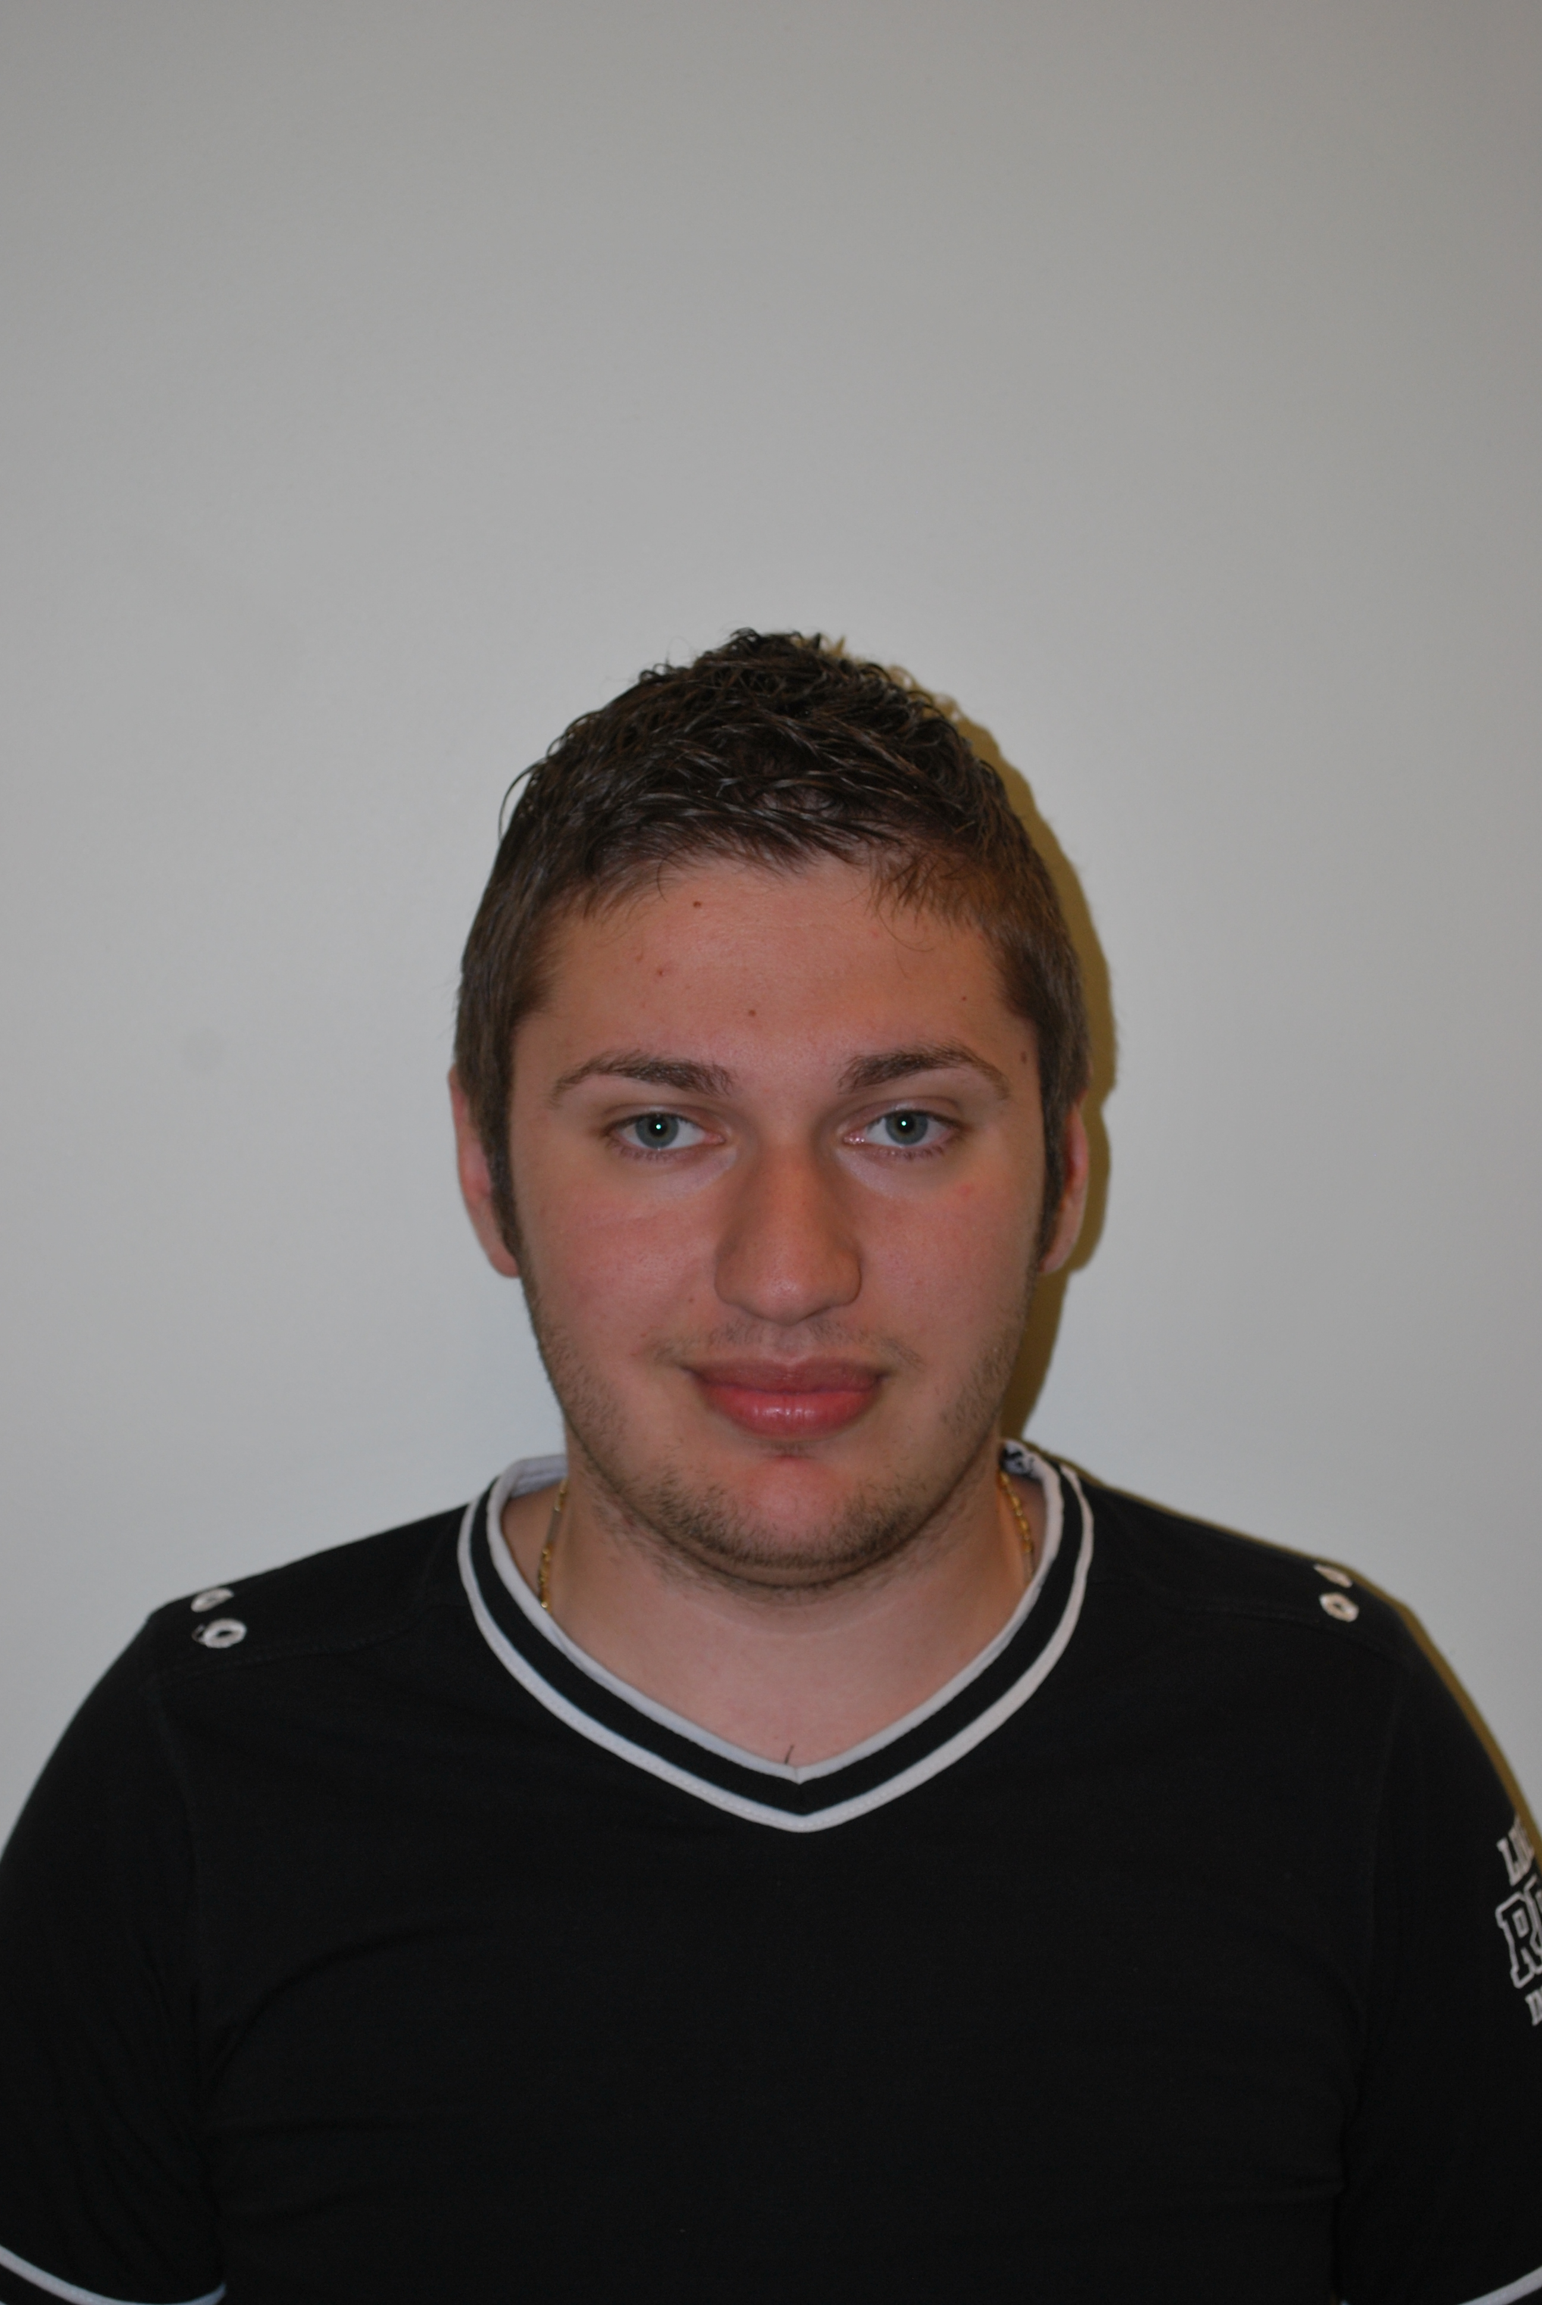
Europass
Curriculum Vitae
Personal information
First name(s) / Surname(s) |  | Matystiak Ionut Ciprian
Address(es) |  | Str.Aleea Pades bl.2,sc.b,ap.7 Resita Caraş-Severin, România
Telephone(s) |  |  |  |  |  |  | Mobile: |  |  |  | 0766706839
Fax(es) |  | -
E-mail |  | cipriani92@yahoo.com
Nationality |  | romanian
Date of birth |  | 08.03.1992
Gender |  | male
Desired employment / Occupational field |  | -
Work experience |  | -
Education and training
Dates |  | 2011 - present
Title of qualification awarded |  | Student in the first year in Electrical engineering in the electrical, electronic and computers domain.
Principal subjects/occupational skills covered |  | Mathematics and Computers
Education and training |  | High School "Mircea Eliade” Resita, specialization:Mathematics
Dates |  | 2007-2011
Title of qualification awarded |  | High school graduation certificate  Baccalaureate diploma  Certificate of advanced level language skills in German
Principal subjects/occupational skills covered |  | Mathematics and Computers
Mother tongue(s) |  | Romanian
Other language(s) |  | German,English
Self-assessment |  |  | Understanding |  |  |  |  | Speaking |  |  |  |  | Writing
European level (*) |  |  | Listening |  | Reading |  |  | Spoken interaction |  | Spoken production
German,English |  |  | A1 |  | B1 |  |  | A2 |  | A2 |  |  | A2
 |  | (*) Common European Framework of Reference for Languages
Social skills and competences |  | Able to work in a team and under stress, quick adaptability to changes, comunication
Technical skills and competences |  | PC knowledge
Computer skills and competences |  | Software – medium level: installation  Windows XP, Vista, 7; Office (MS, Open Office) –Medium;
Other skills and competences |  | Hobby: PC in general,Table Tennis,Soccer,
Additional information |  | Session of students scientific problems, University Eftimie Murgu

