

Europass  Curriculum Vitae |  | 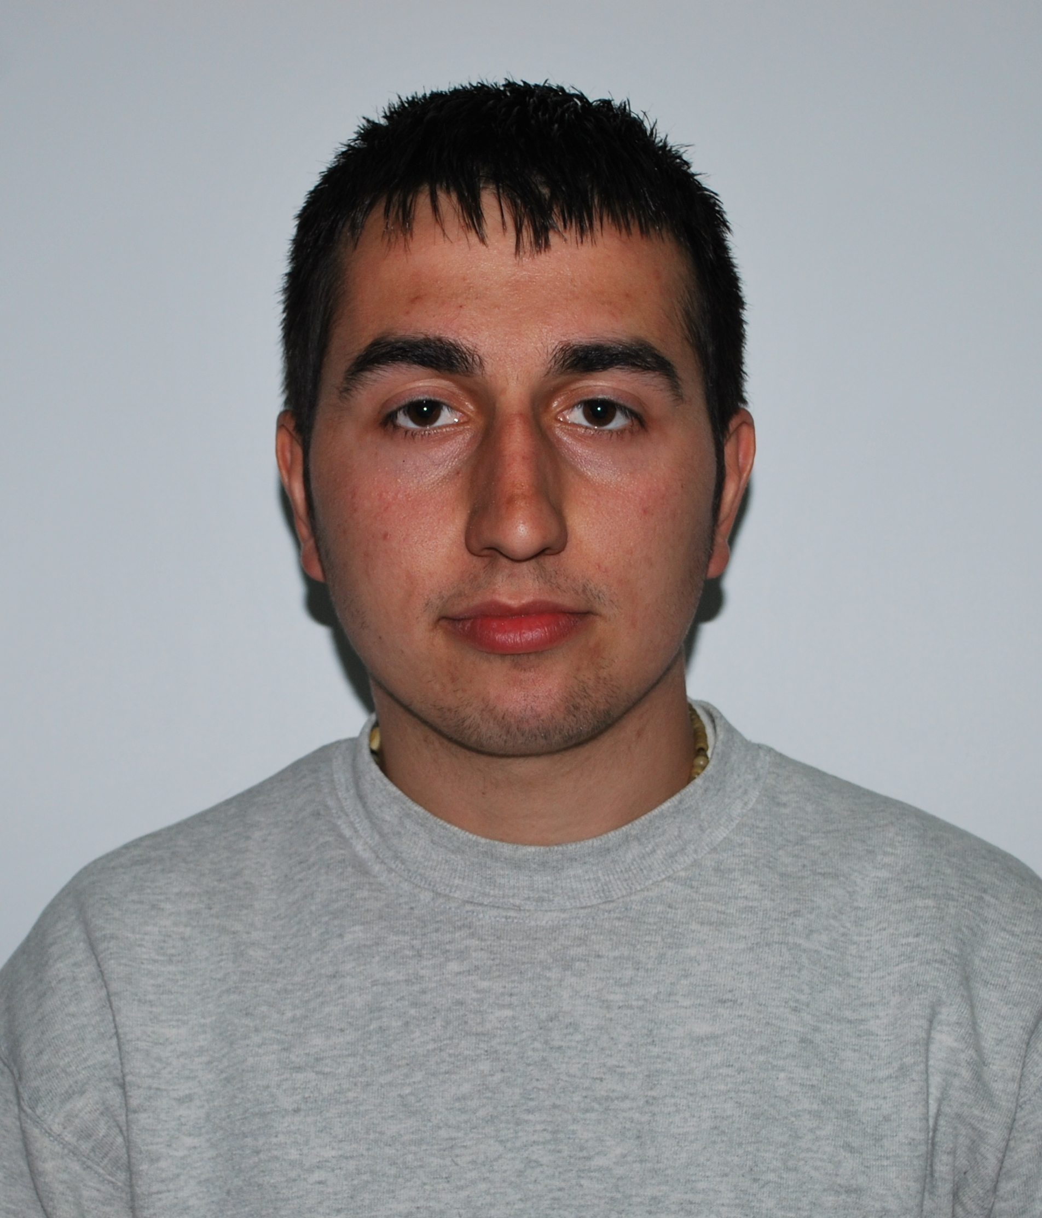
Personal information
First name(s) / Surname(s) |  | SĂRMĂŞAN ALEXANDRU-LAVINIU
Address(es) |  | Bl 8, Sc 6, Ap 19, Bld. Republicii, Resita, Romania
Telephone(s) |  |  |  |  |  |  | Mobile: |  |  |  | +40749370082
E-mail |  | ever_alexandru@yahoo.com
Nationality |  | romanian
Date of birth |  | 09.05.1990
Gender |  | male
Education and training
Dates |  | 2009-present
Title of qualification awarded |  | Thyrd year of Economical Engineering in the Electrical, Energetic and Electronic domain.
Principal subjects/occupational skills covered |  | Production management, operational research
Name and type of organisation providing education and training |  | Student at University Eftimie Murgu Resita, Faculty of Engineering and management, department:Economical Engineering.
Dates |  | 2005-2009
Title of qualification awarded |  | Tourism technician, level 3 degree of professional qualification
Principal subjects/occupational skills covered |  | Study of product and services quality  Accounting  Enterprise economy  Business financing
Name and type of organisation providing education and training |  | Economical College of BANATUL MONTAN RESITA
Personal skills and competences
Mother tongue(s) |  | Romanian
Other language(s) |  | English
Self-assessment |  |  | Understanding |  |  |  |  | Speaking |  |  |  |  | Writing
European level (*) |  |  | Listening |  | Reading |  |  | Spoken interaction |  | Spoken production
English |  |  | B2 | Experienced user | B1 | Experienced user |  | B2 | Basic user | B2 |  | Independent user | C2 | Independent user
 |  | (*) Common European Framework of Reference for Languages
Social skills and competences |  | Teamwork experience
Computer skills and competences |  | Word, Excel, Power-Point, Access, C, C++, FoxPro
Artistic skills and competences |  | Graphics
Other skills and competences |  | Hobby: soccer, tenis, scuba diving, swiming.
Driving licence |  | B category
Additional information |  | 2011- Timisoara, Actual Challenges in Logistics and Maintenance of Insustrial System

