

Europass  Curriculum Vitae |  | 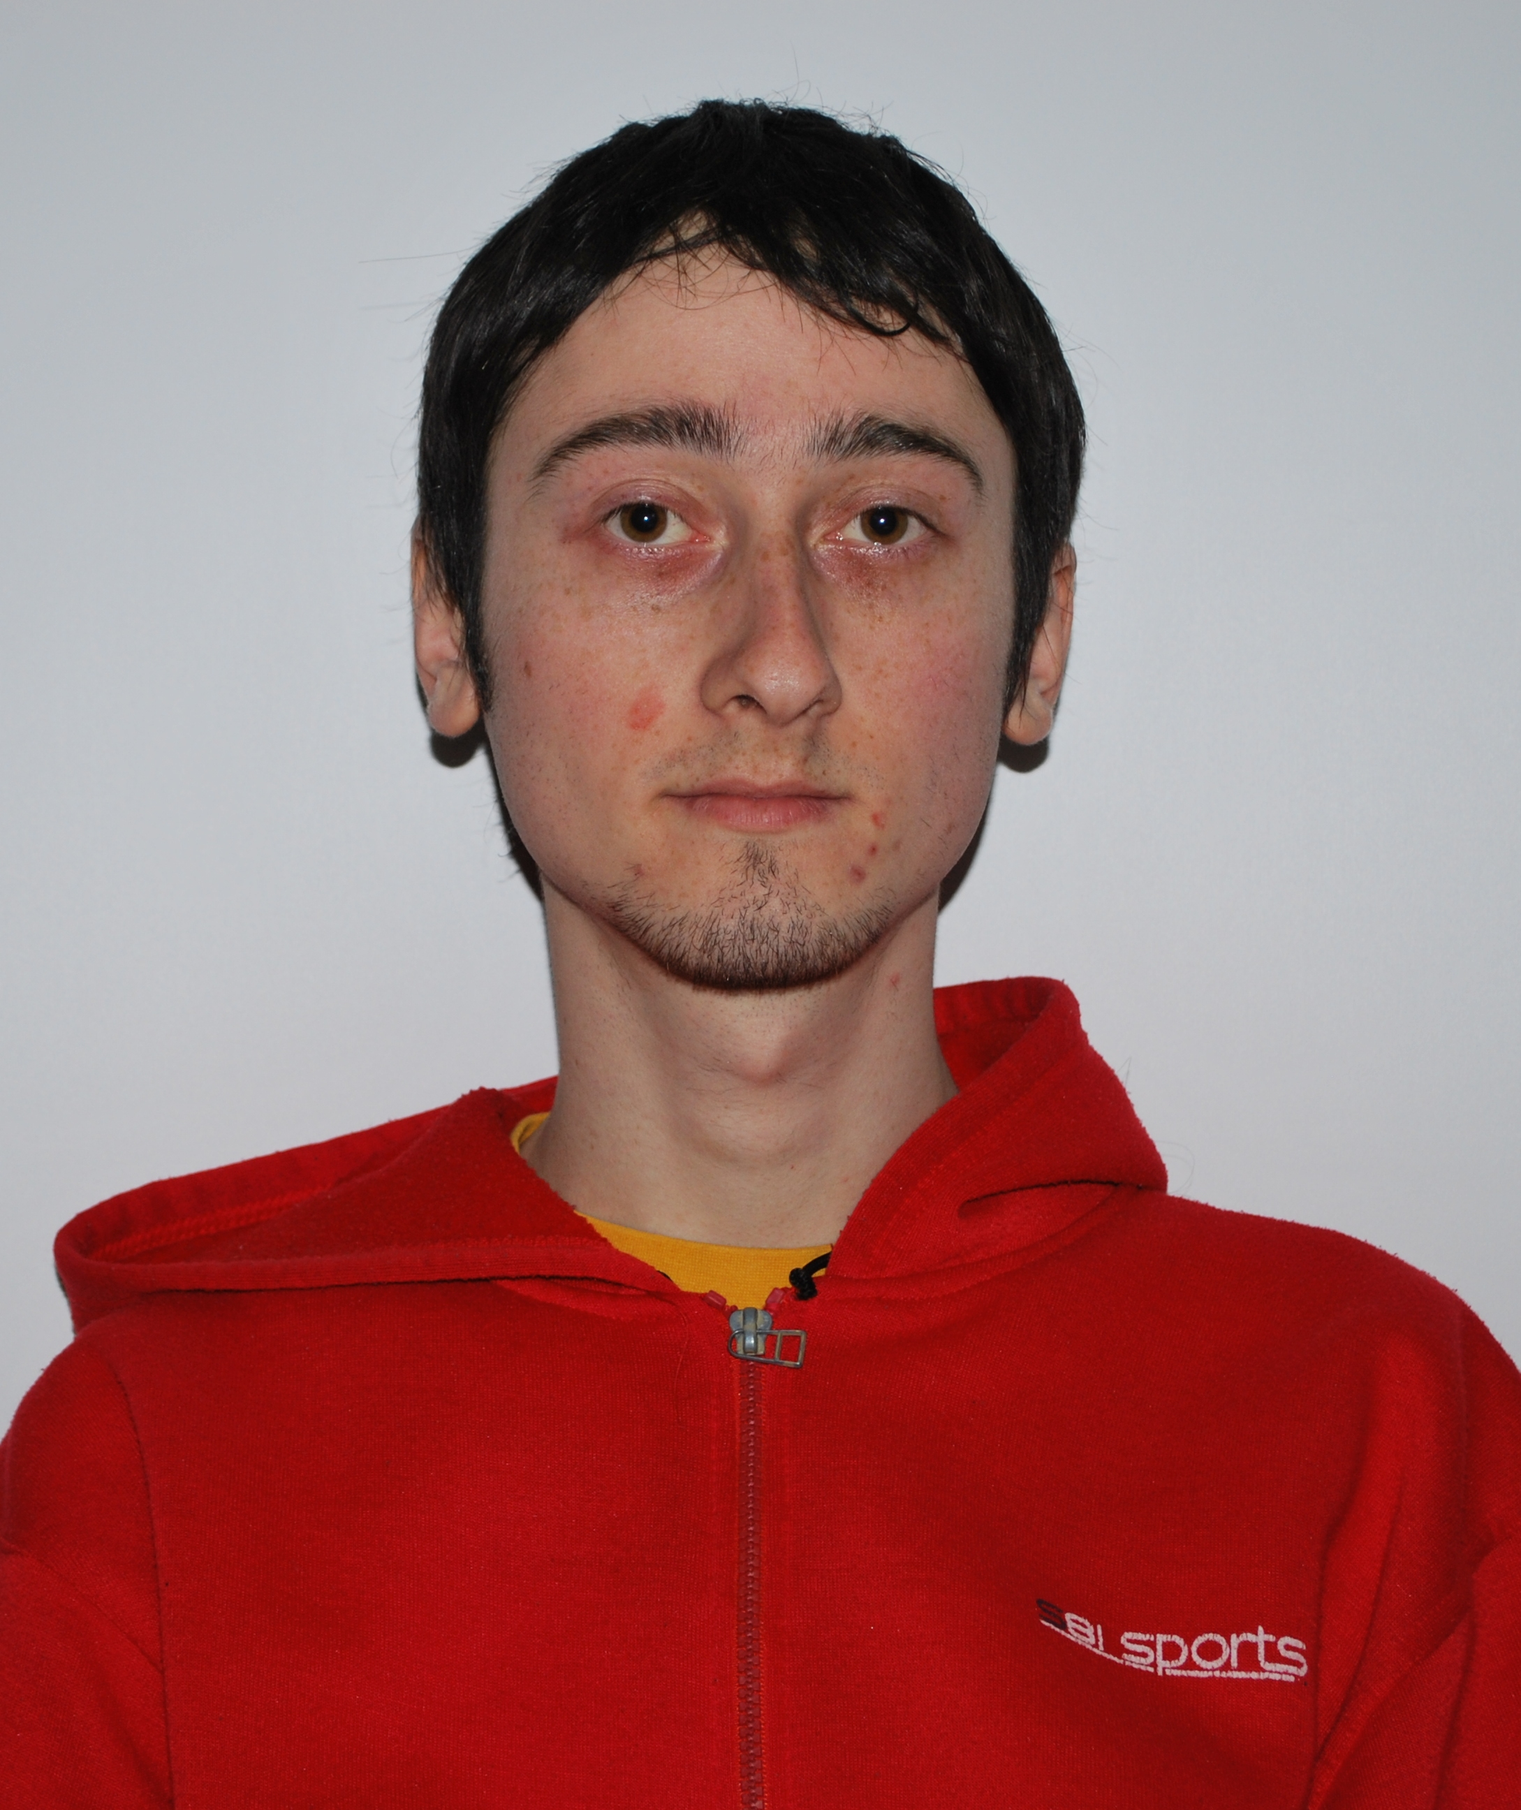
Personal information
First name(s) / Surname(s) |  | Ungureanu, Victor Stefan
Address(es) |  | Sc. B nr:29, Str. Fagaras, postcode: 320217, Resita, Romania
Telephone(s) |  | Mobile: |  |  |  |  |  |  |  | 0040745883659
E-mail |  | Victor_ungureanu89@yahoo.com
Nationality |  | Romanian
Date of birth |  | 26.12.1989
Gender |  | Male
Education and training
Dates |  | 2009-present
Title of qualification awarded |  | Thyrd year of Economical Engineering in the Electrical, Energetic and Electronic domain.
Principal subjects/occupational skills covered |  | Production management, operational research
Name and type of organisation providing education and training |  | Student at University Eftimie Murgu Resita, Faculty of Engineering and management, department:Economical Engineering.
Dates |  | 2005-2009
Title of qualification awarded |  | High-school Graduation  Certificate of advanced level language skills in English
Principal subjects/occupational skills covered |  | English - speaking, talking and writing.
Name and type of organisation providing education and training |  | Teoretical Highschool Mircea Eliade, Resita
Personal skills and competences
Mother tongue(s) |  | Romanian
Other language(s) |  | English
Self-assessment |  |  | Understanding |  |  |  | Speaking |  |  |  |  | Writing
European level (*) |  |  | Listening |  | Reading |  | Spoken interaction |  | Spoken production
English |  |  | C2 |  | C1 |  | B2 |  | B2 |  |  | B2
 |  | (*) Common European Framework of Reference for Languages
Social skills and competences |  | Able to speak in front of a large audience.  May work in a team.  Quick adaptability to changes.
Technical skills and competences |  | Able to work with a computer.
Computer skills and competences |  | Microsoft office word, powerpoint, excel- advanced level  Windows OS - medium level.
Artistic skills and competences |  | Able to draw 3 dimensional figures.
Other skills and competences |  | Hobby: Computer and electronics
Additional information |  | 2011- Timisoara, Actual Challenges in Logistics and Maintenance of Insustrial System
Driving licence |  | None

