 |  | 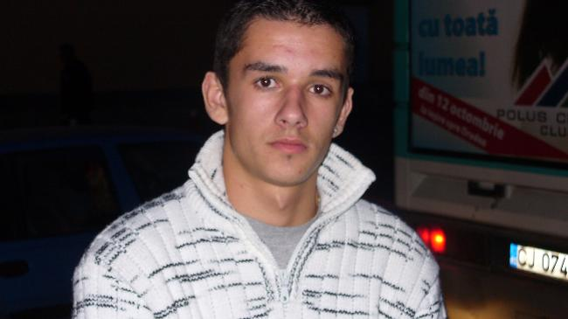
Europass
Curriculum Vitae
Personal information
First name(s) / Surname(s) |  | Boldan Marius Ovidiu
Address(es) |  | Baia Mare, jud Maramures, str Marasesti, bloc 7/28, Romania
Telephone(s) |  | Mobile: 0743110503
E-mail |  | marius_boldan007@yahoo.com
Nationality |  | Romanian
Date of birth |  | 11.04.1990
Gender |  | M
Desired employment / Occupational field |  | Student
Education and training |  | Graduate of „ Anghel Saligny technical college” Baia Mare
Dates |  | 2009 promotion
Title of qualification awarded |  | Bacalaureat
Principal subjects/occupational skills covered |  | Technical drawing ,mathematics , physics
Level in national or international classification |  | Certificate of professional qualification level 3  Mecatronic Technician, Technical Profile
Personal skills and competences
Mother tongue(s) |  | Romanian
Other language(s) |  | English ,French ,Spanish
Self-assessment |  |  | Understanding |  |  |  |  | Speaking |  |  |  |  | Writing
European level (*) |  |  | Listening |  | Reading |  |  | Spoken interaction |  | Spoken production
English |  |  |  | Medium |  | Medium |  |  | Medium |  |  | Medium |  | Medium
French |  |  |  | Medium |  | Medium |  |  | Medium |  |  | Medium |  | Medium
 |  | (*) Common European Framework of Reference for Languages
Social skills and competences |  | Certificate of Business Ethics
Organisational skills and competences |  | Interpersonal relationship management
Technical skills and competences |  | Health and safety  Systems for transmission of movements  Manufacturing systems and technology  Measurement techniques in the field  Automation  mechanical assembly  Electric Actuators in Mechatronics  Pneumatic Actuators in Mechatronics  Hydraulic in mechatronics  mechatronic systems
Computer skills and competences |  | Computer and information processing  Using CAD applications  Ofiice  Elements of design  Computer operating  Catia  Inventor
Other skills and competences |  | Certificate of professional competence, qualifications Painter, decorator, painter
Driving licence |  | Cat. B from 2008
Additional information
Qualities  Hobbies |  | Communicative, I adapt easily, teamwork, friendly, receptive to new things  Folk dance, football, fishing

